

National Textile University
Department of Computer Science

Subject:
Mobile Application Development

Submitted to:
Sir Rehan

Submitted by:
Asbah Asif

Reg number:
23-NTU-CS-1141

Lab no.:
02

Semester: 6th
- All 4 tasks are in the same file and separated by divider.
- I attached separate Code snap of each task.
- Final output is at ends.

Task 1:
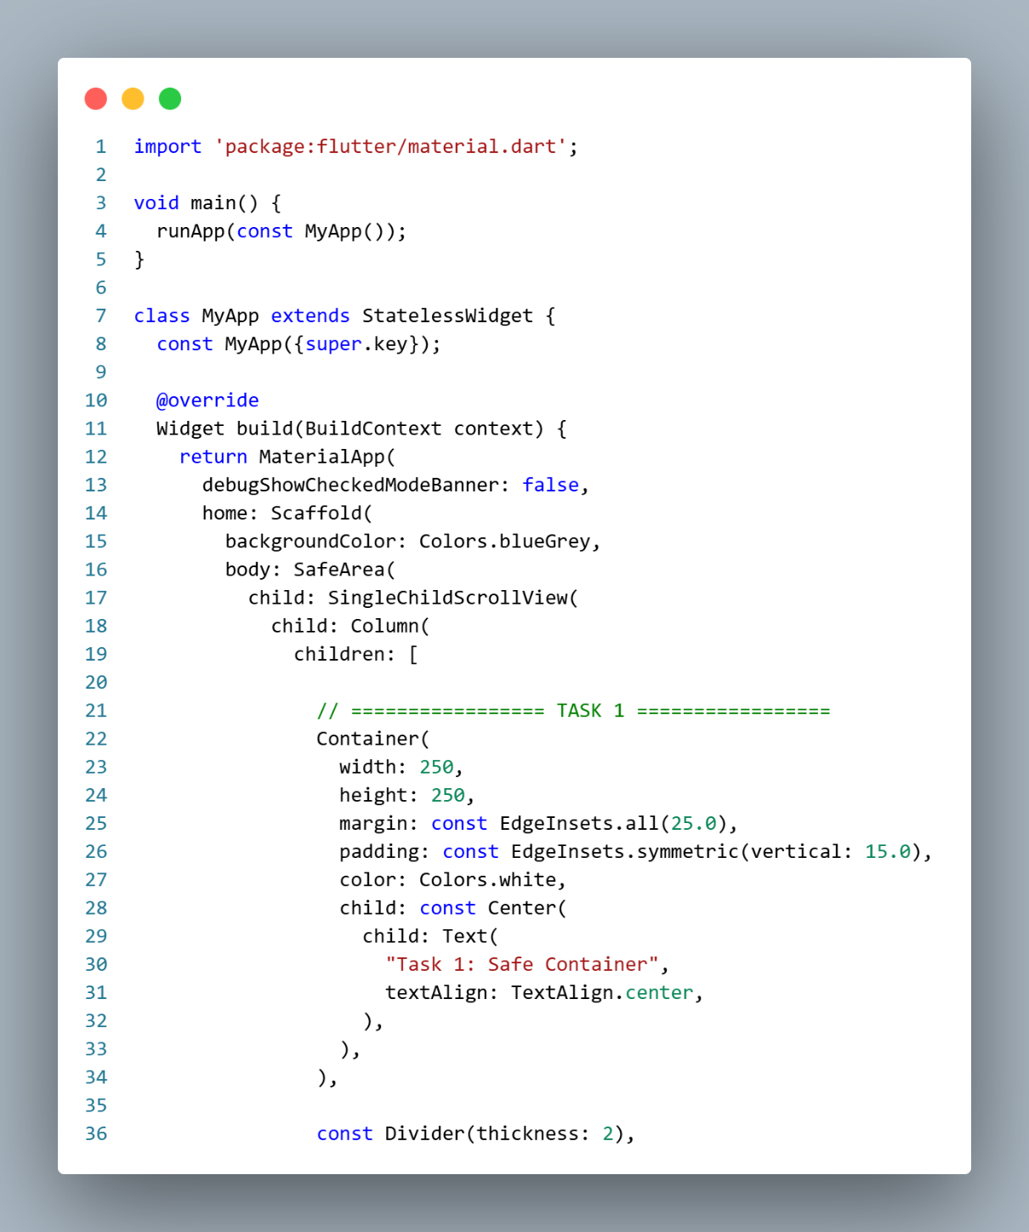

Task 2:
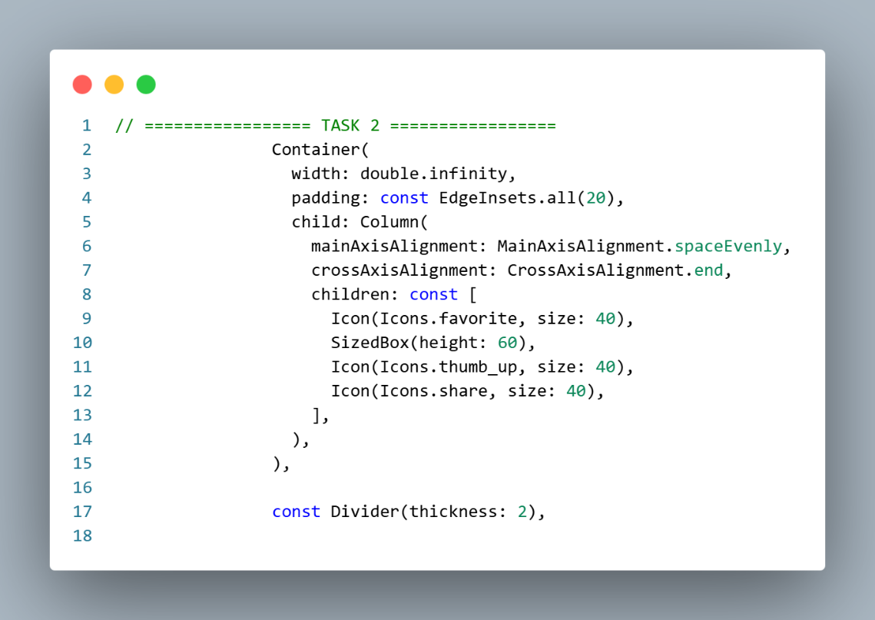

Task 3:
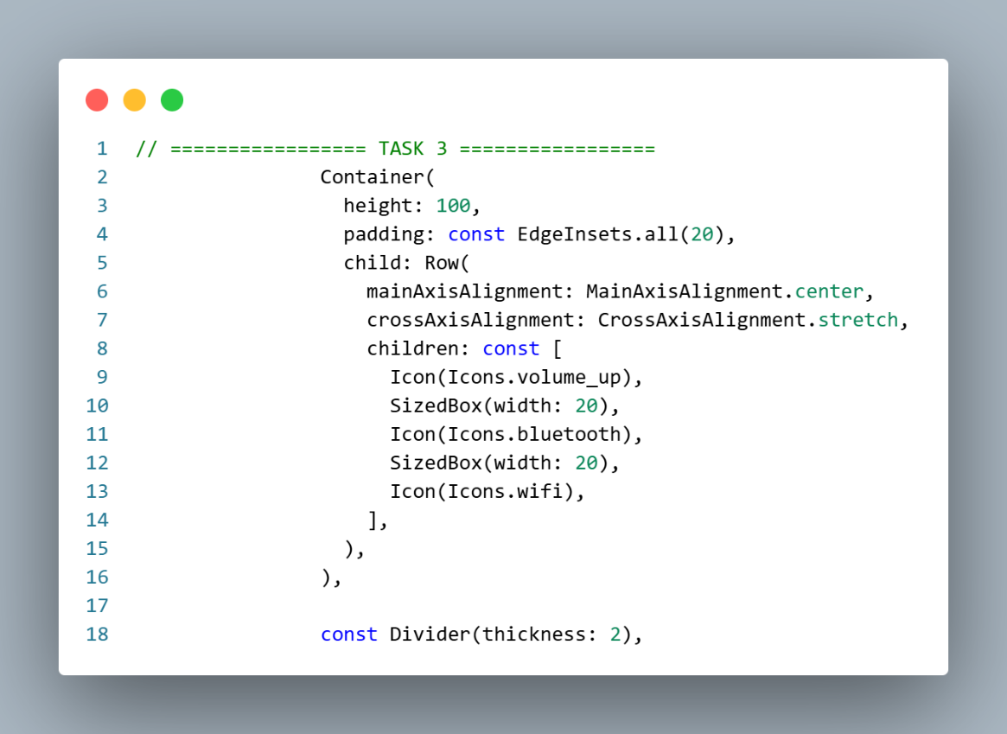
Task 4:
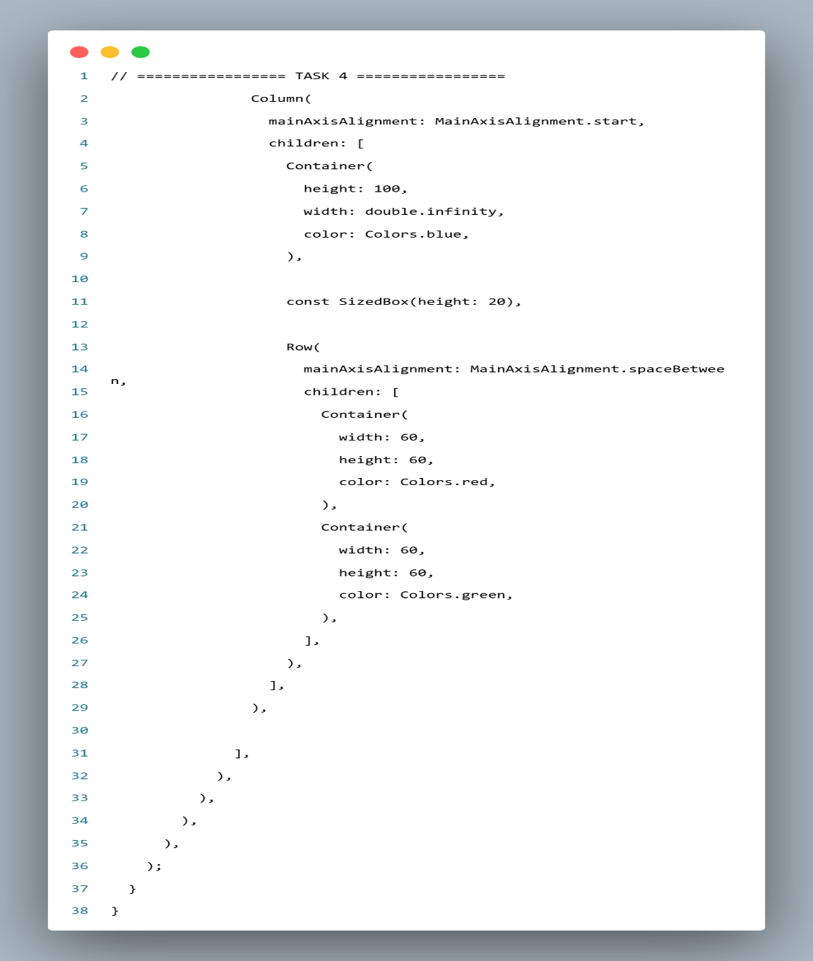

Output:
